Dhwani Foundation- Bangalore & Thozhi Federation- Tamil Nadu
Jointly Organized by
2nd Niranthara Lite Organizational Development (OD) two days Training program for Federation Members
DAY-1
Training No : 02
Date : 20-12-2024 - Friday
Name of the
Training : Organizational Development program for Federation Members
Time : 10.00 A.M to 6.00 P.M
Venue : CRDS Training Centre,
Kasiyampatti-Dharmapuri

Agenda:
- Welcome Address
- Recap of Before Training
- Training Module Introduction
- Governance Module
- Finance and Accounting
- Practical Session
- Parameters Explanation
Thozhi Federation and Dhwani Foundation have to organized the two days training on 1st Niranthara Lite Organizational Development Program Training for Federation Members. In the Training 15 Member Organization have been participated. Mr. Sivakumar, Thozhi Federation CEO delivered the welcome Address.

Recap of the Before Training:
Miss. P. Jayavarshini ,to recap the before training, Compliance and Program Management . To implement the parameters and POSH, CPP Policy. And the participants have to explain about the before training and followup.
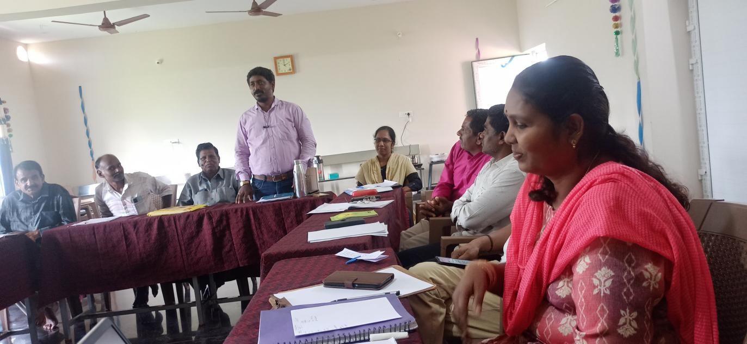
Training Participants:
- Mrs. Devaki -Sri Devi Maha Educational and Charitable Trust – Dharmapuri
- Mrs. Saranya – Bommanur Society – Dharmapuri
- Mrs. Nagalakshmi – Nithenika Educational Charitable Trust – Karur
- Mr. Thirumoorthy – SEED Trust – Karur
- Mr. Murugesan -Amirdha Trust – Karur
- Mr. Govindaraj – Integrated Social Service Organization - Krishnagiri

- Mr. Malaiyarasan – SundraTamil Charitable Trust – Tirupattur
- Mr. Elumalai – Kamarajar Trust – Tiruvannamalai
9.Mr. Dhasarathan – Village Women Development Society – Tiruvannamalai
10. Mr. Raju – Village Development Centre – Tirchy
11. Mrs. Seethalakshmi – Women Development Planning Society – Tirchy
12. Mrs. Gunaseli – Women Education Development Trust – Tiruppur
13. Mr. Somasundaram – EDISAN Trust – Tiruppur
14. Mr. Radhakrishan – Sevagan Trust – Vellore
Training Module Introduction:
Mr. Ayyapan, Dhwani Foundation – To explain about the Dhwani Foundation and Nrianthara Lite Program Training. The Training is to develop the Organizational and Strengthening the NGO in the Manual. This 2nd training must be focused Governance and Finance and Accounting.
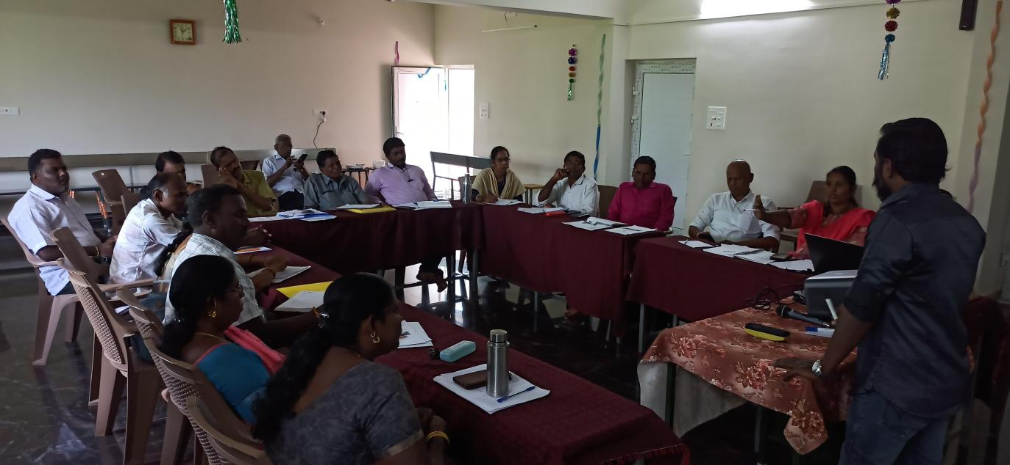
1st Session:
Governance Module:
- Board Self-Assessment
First, we have to analysis the board self- assessment. Every members should have to analysis there self.
- Objectives of Governance:
Participants develop knowledge on making board more effective through understanding their key roles and methods of good governance.
Social sector Impact:
- Legal
- Depends upon the state laws
- Laws designate overall responsibility and liability
- Legal obligation (renewal registration)
- Ethical
- Private Benefit taking
- Board assumes the responsibility and achievement
- Go beyond legal to ensure organisation not only does things rights but does not right things
- Stakeholders trust and expect quality services
- Practical
- Board members were various hats depending the need of the moment
- Board devote its time to governing, providing direction and securing that the mission of the organization stays on course.
- Board is the body that provide continuous to the organization individual come and go but the board ass an entity remark
- Good practise are institutionalized
Governance | Good Governance
Leadership, Decision Making, Transparent | Participatory, Orientation, Rule of law, Responsive, Effective and Efficient, Accountable, follow the rule of law
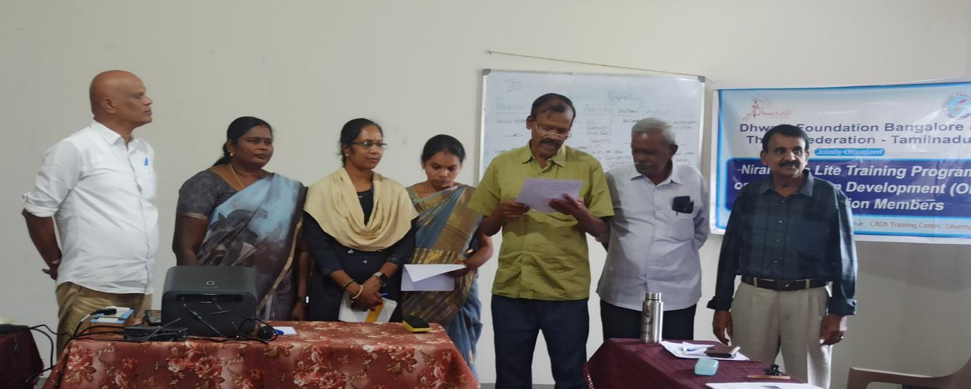
Membership of the Board:
Trust:
- Board trustees shall have a minimum of two members
- Appointment of the trustee should be done formally, in writing, followed by board resolution.
- Name, Address and other details of the board of trustee must be mentioned in the trust deed
- In case, addition removal or any other change in the member of the board, the board shall conduct a meeting wherein the decision will be put a vote.
- Various designation and to be appointed to specific post
- The tenure of the trustee and their designation
- The appointment letter Manging trustee to singed on the all members, and financial trustee have to signed for Manging trustee

Society:
- 7 Members should have in the Board members
- Name, Address and other details of the board of trustee must be mentioned in the society
- In case, addition removal or any other change in the member of the board, the board shall conduct a meeting wherein the decision will be put a vote.
- Various designation and to be appointed to specific post
- No law to mandate diversity
- Diverse background (Gender, regional, expertise)
Independent Board:
- Duty of loyalty – put the interest of the organization above personal interest
- Conflict of interest policy
- A substantial majority of the board (usually meaning at least two-thirds of the members) should be independent
Decision making by General Body:
- Annual General Body Meeting
- Appointment of Auditor
- Election of office bearers
- Amendment of bye-law
- Purchase of large properties
Good Governance practices for trust and society:
- Membership
- Age limit
- Role of office bearers
- Tenure
- Diversity
- Gender
- Community representation
- Procedure for resignation
- Removal of members
- Appointment of CEO
- Rotation policy (Board authority changes)
- Roles and responsibility of members
- Amendments
Recruitment of Body Meeting:
- Time of resignation (6months)
- Byelaw mentioned the board members roles and responsibilities
- Enrol a potential board member as a volunteer
- Opportunity for the new person to become families with an organizations vision, mission
- Every decision is formally discussed in the board and documented
Board Meeting Overview:
- Governance, strategic plan, Accountability
- Compliance, vision and Mission, Decision-Making
- Beneficiary Members
- Quarterly Meeting
Types of Board Meeting:
Types | Agenda sending time period
- Annual General Body Meeting | 21 days before
- Extra-Ordinary/Special Meeting | 7 days before
- Emergency Meeting | 3 or 4 days before

Notice of Meeting:
- Nature of meeting
- Place of meeting
- Time and date
- Agenda
- Circulate pre-reading material prior to the board
- Minutes of the previous meeting
- Inform the board if a quarter
- Any other matters
Finance Statement:
The board should check the receipt, payment, income & expenditure, Balance sheet, asset. In the quarterly meeting board should identify the Budget vs actual, status of compliance, cash position.
CEO roles in the board:
- High quality service
- Long-term view and innovative thinking
- Work with board and inform the board regularly
- Reach out the community to present NGO
Board Meeting Minutes:
- Meeting No
- Organization Name and address
- Date, venue
- Present an absent
- Welcome note
- Agenda
- Resolution minutes/ with acceptance
- Vote of thanks
Signature

2nd Session:
Parameters Explanation:
The 2nd Session chaired by Mr. Shankar and Miss. Jayavarshini
In the Session, explained about the Niranthara Parameters. Governance, Finance and Accounting

DAY-2
Training No : 02
Date : 21-12-2024 / Saturday
Name of the Training :Organizational Development program for Federation Members
Time : 10.00 A.M to 3.00 P.M
Venue : CRDS Training Centre,
Kasiyampatti-Dharmapuri
Finance & Accounting:
Internal control:
Rules, Policy, Procedure
Financial management:

Types of financial Management:
- Cash
- Bank
- Fund
- Account
- Salary
Petty Cash:
- Rs.10000/-
- Surprise check of petty cash register
- Petty cash box [cashier]-to cross check [Accountant]-surprise check [secretary, president]
- In the petty cash including coin also
Petty cash Book:
S. No | Date | Particulars | Income | Expense | Balance
1 | 01/11/2024 | Tea and snacks | 1000 | 100 | 900

Cash Management system:
- Day today entry – cashier signature
- Verify (verification signature must)
- Surprise visit (Accountant, president, secretary)
Bank management system:
- Signing authority for 2 board members in the cheque and open the joint account
- Maintenance cheque issue register
Records and Register:
- Attendance register
- Leave register
- Salary register
- Loans and Advance register
- Copies of consultant agreements
Asset Management:
- 5000 rupees beyond purchase to use procedure
Procurrent process:
- Need recognition
- Purchase requestions
- Review of request
- Budget approval
- Quotation request
- Negotiation and contract
- Receive goods/services
- Three-way matching
- Invoice approval payment
- Record keeping
Fixed Asset Register:
- One for purchase
- For donation in king
- In electronic depreciation is 40%
Receipt Book:
- Printed receipt book
- Address, Name of the org, Logo, contact details
- Serial no
- Corban copies
- 80G receipt need for donation Rs.2000 beyond
Cash Transaction Register:
- Zero cash transaction and completely through bank
- Regular expenditure to be made through cheque/online payment including employee salaries and reimbursement
- Every transaction to have supporting documents
- Balance sheet and audited income and expenditure statement to be included in the annual report
Budget:
How to prepare the budget for the federation.
Forms:
- Leave register
- Salary register
- Budget plan
- Asset register
- Purchase order register
- Travel allowance register
- Receipt
- Voucher
- Cash transaction register
- Cheque issue register
- Petty cash register

Conclusion:
The two days is very useful for all members NGO. The training must be trained the details of complains and CPP, POSH. We have to strengthening our Member NGO and its reached 100% successful Organization. The Participants also more involved in every session.
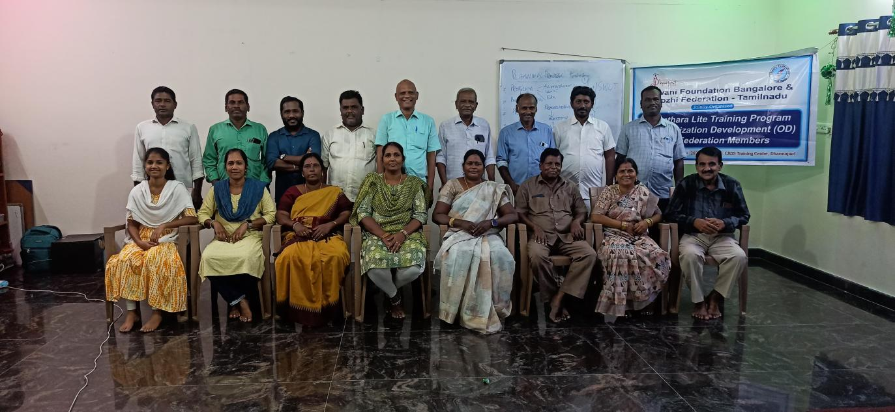

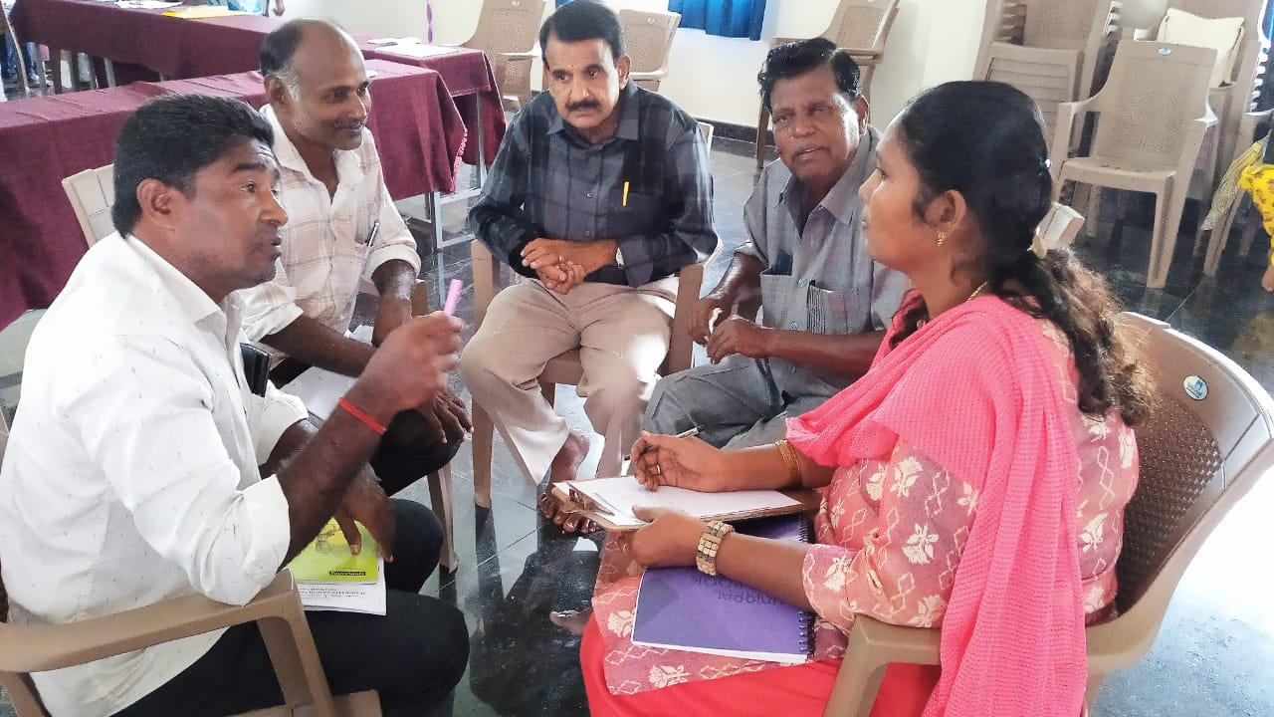

Attendance :

